Monolithic Architecture
# Source: AI Source: Provided by: [Data Path: Persons Table -> ID Column: 1, Name_En Column: Motasem Essam] -> From: [ChatGPT] on [1/23/2026]
Monolithic Architecture is one of the simplest and oldest forms of software design. In a monolithic system, all components of the application (UI, business logic, data access) are combined into a single codebase and deployed as one unit.
👉 Think of it like a single, large block—everything is connected and runs together.

🔑 Key Points
# Source: AI Source: Provided by: [Data Path: Persons Table -> ID Column: 1, Name_En Column: Motasem Essam] -> From: [ChatGPT] on [1/23/2026]
- Single, unified codebase
- One deployable application
- Components are tightly coupled
- Easy to start small, but can grow complex

🧱 Structure Example
# Source: AI Source: Provided by: [Data Path: Persons Table -> ID Column: 1, Name_En Column: Motasem Essam] -> From: [ChatGPT] on [1/23/2026]
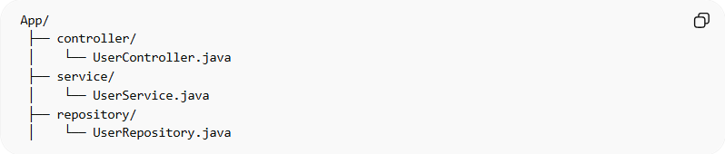
App/
├── controller/
│ └── UserController.java
├── service/
│ └── UserService.java
├── repository/
│ └── UserRepository.java
- UserController → handles requests
- UserService → contains business logic
- UserRepository → manages data storage

❌ Common Problems
# Source: AI Source: Provided by: [Data Path: Persons Table -> ID Column: 1, Name_En Column: Motasem Essam] -> From: [ChatGPT] on [1/23/2026]
- Difficult to scale only parts of the app
- Tight coupling makes testing harder
- Over time, can become a “big ball of mud”
- Hard to maintain when the codebase grows

✅ Benefits
# Source: AI Source: Provided by: [Data Path: Persons Table -> ID Column: 1, Name_En Column: Motasem Essam] -> From: [ChatGPT] on [1/23/2026]
- Simple to develop and deploy for small projects
- Easy to test initially
- Good choice for small teams or MVPs

⚡ When to Use
# Source: AI Source: Provided by: [Data Path: Persons Table -> ID Column: 1, Name_En Column: Motasem Essam] -> From: [ChatGPT] on [1/23/2026]
- Small to medium-sized applications
- Quick development is needed
- Team size is small
- No immediate need for independent service scaling

